**Important Biology Diagrams for Your Exam**

**Cell Structure**

**1. Plant Cell**

* **Key features:** Cell wall, chloroplasts, large central vacuole

[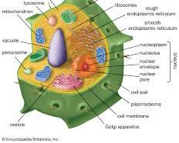Opens in a new window[](https://www.britannica.com/science/plant-cell)www.britannica.com](https://www.britannica.com/science/plant-cell)

plant cell

**2. Animal Cell**

* **Key features:** No cell wall, centrioles, smaller vacuoles

[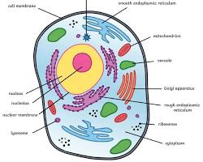Opens in a new window[](https://www.twinkl.com/teaching-wiki/animal-cell)twinkl.com](https://www.twinkl.com/teaching-wiki/animal-cell)

animal cell

**3. Bacterial Cell**

* **Key features:** Prokaryotic, no nucleus, single circular chromosome

[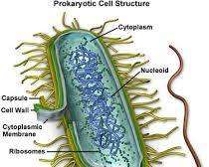Opens in a new window[](https://micro.magnet.fsu.edu/cells/bacteriacell.html)micro.magnet.fsu.edu](https://micro.magnet.fsu.edu/cells/bacteriacell.html)

bacterial cell

**4. Nucleus**

* **Key features:** Control center of the cell, contains DNA

[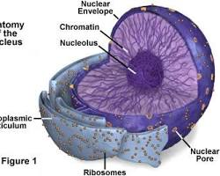Opens in a new window[](https://micro.magnet.fsu.edu/cells/nucleus/nucleus.html)micro.magnet.fsu.edu](https://micro.magnet.fsu.edu/cells/nucleus/nucleus.html)

nucleus

**5. Mitochondria**

* **Key features:** "Powerhouse of the cell," produces ATP through cellular respiration

[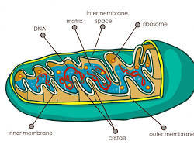Opens in a new window[](https://www.medicalnewstoday.com/articles/320875)medicalnewstoday.com](https://www.medicalnewstoday.com/articles/320875)

mitochondria

**6. Chloroplasts**

* **Key features:** Found in plants, perform photosynthesis to produce glucose

[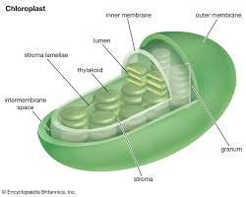Opens in a new window[](https://www.britannica.com/science/chloroplast)www.britannica.com](https://www.britannica.com/science/chloroplast)

chloroplasts

**Cell Processes**

**7. Mitosis**

* **Key features:** Cell division resulting in two identical daughter cells

[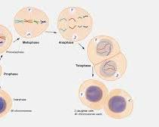Opens in a new window[](https://www.genome.gov/genetics-glossary/Mitosis)www.genome.gov](https://www.genome.gov/genetics-glossary/Mitosis)

mitosis

**8. Meiosis**

* **Key features:** Cell division resulting in four genetically different daughter cells

[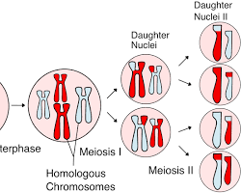Opens in a new window[](https://en.wikipedia.org/wiki/Meiosis)en.wikipedia.org](https://en.wikipedia.org/wiki/Meiosis)

meiosis

**9. Cell or Tissue Differentiation**

* **Key features:** Process by which cells specialize to perform specific functions

[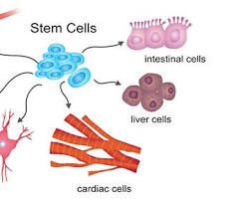Opens in a new window[](https://www.cusabio.com/cytokines/Cell-Differentiation.html)www.cusabio.com](https://www.cusabio.com/cytokines/Cell-Differentiation.html)

cell differentiation

**Molecular Biology**

**10. Enzyme - Substrate Reaction**

* **Key features:** Lock-and-key model, enzyme catalyzes a chemical reaction

[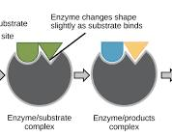Opens in a new window[](https://www.khanacademy.org/science/ap-biology/cellular-energetics/enzyme-structure-and-catalysis/a/enzymes-and-the-active-site)www.khanacademy.org](https://www.khanacademy.org/science/ap-biology/cellular-energetics/enzyme-structure-and-catalysis/a/enzymes-and-the-active-site)

enzymesubstrate reaction

**11. DNA Structure**

* **Key features:** Double helix, composed of nucleotides (adenine, thymine, guanine, cytosine)

[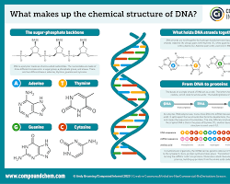Opens in a new window[](https://www.compoundchem.com/2015/03/24/dna/)compoundchem.com](https://www.compoundchem.com/2015/03/24/dna/)

DNA structure

**12. RNA Structure**

* **Key features:** Single-stranded, composed of nucleotides (adenine, uracil, guanine, cytosine)

[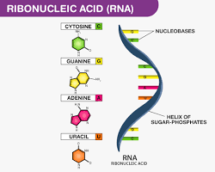Opens in a new window[](https://byjus.com/biology/structure-of-rna/)byjus.com](https://byjus.com/biology/structure-of-rna/)

RNA structure